1. **Creating Rest API**

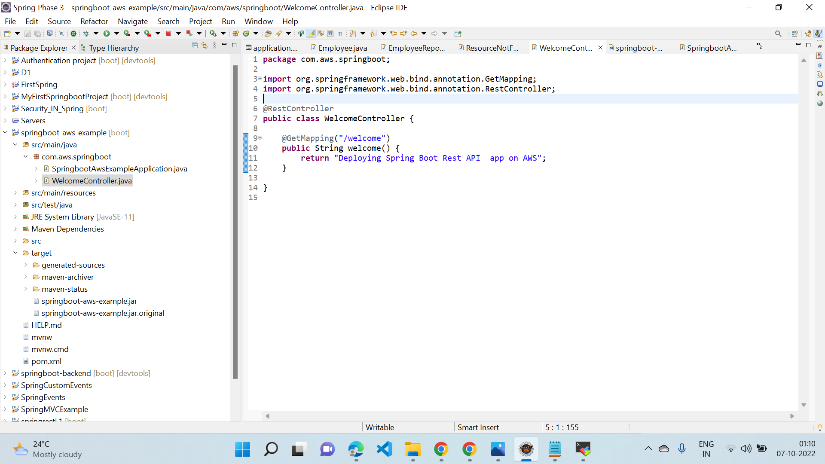

1. **MobaXterm app**

For integration of terminal program, an X server, an SSH client

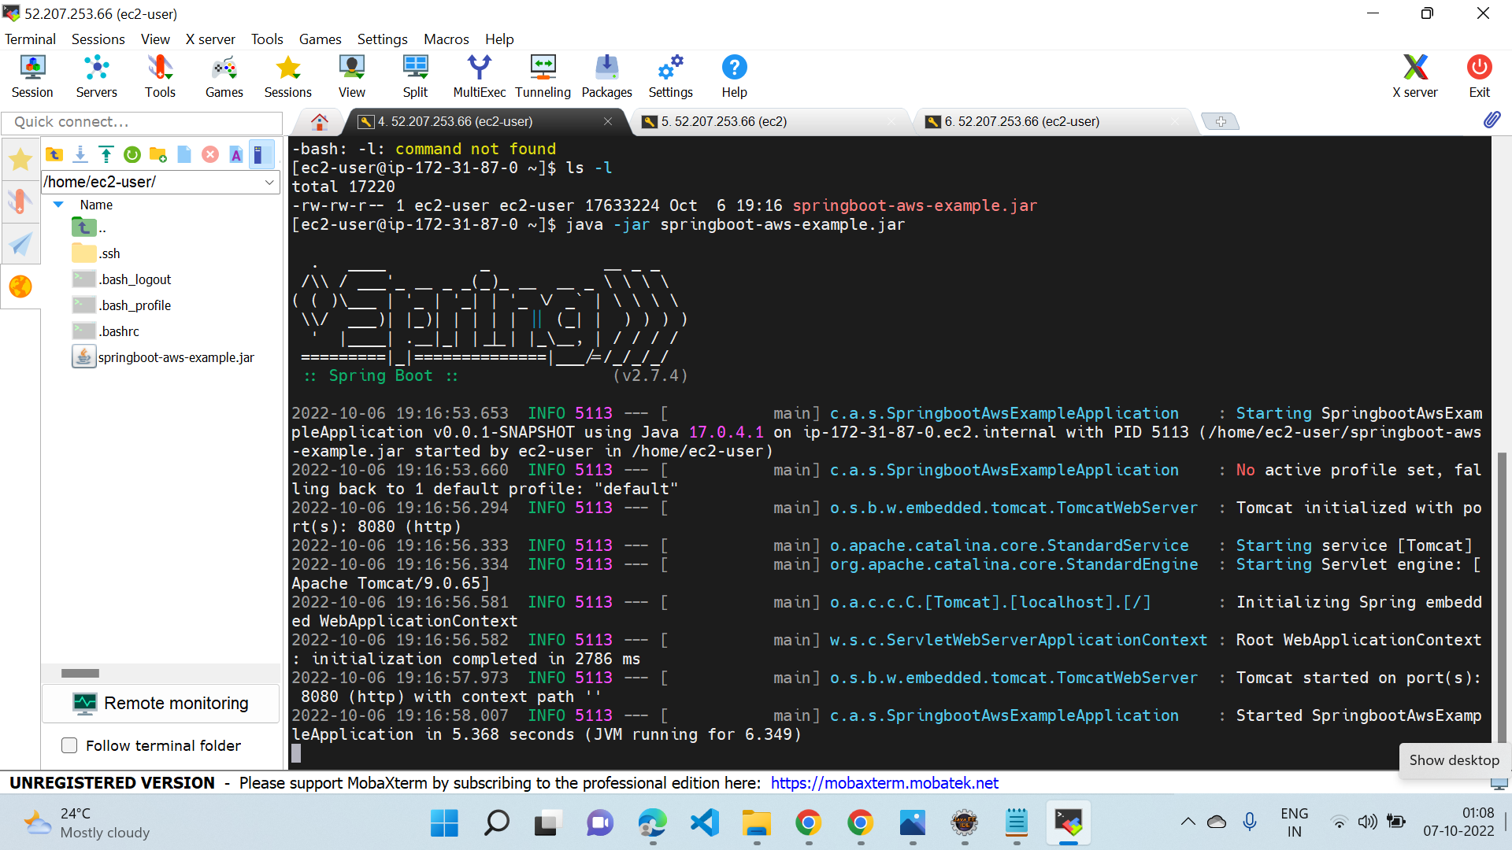

**3.EC2 Instance**

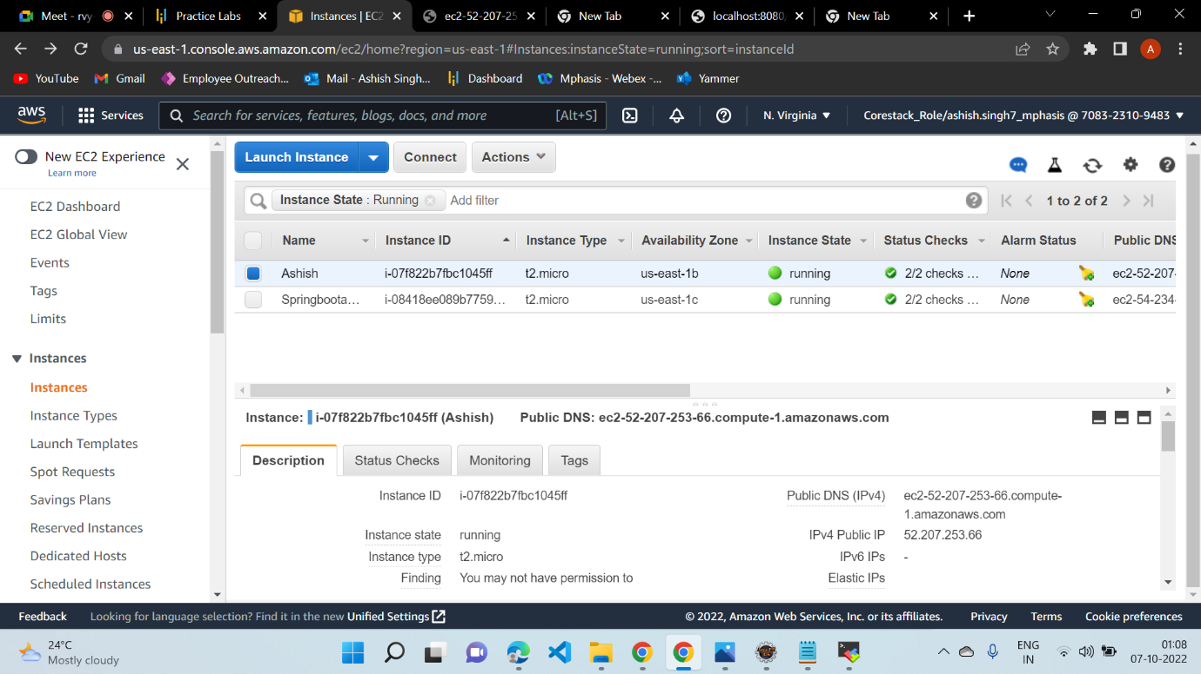

*4 Uploading Source code*

**Jar file**

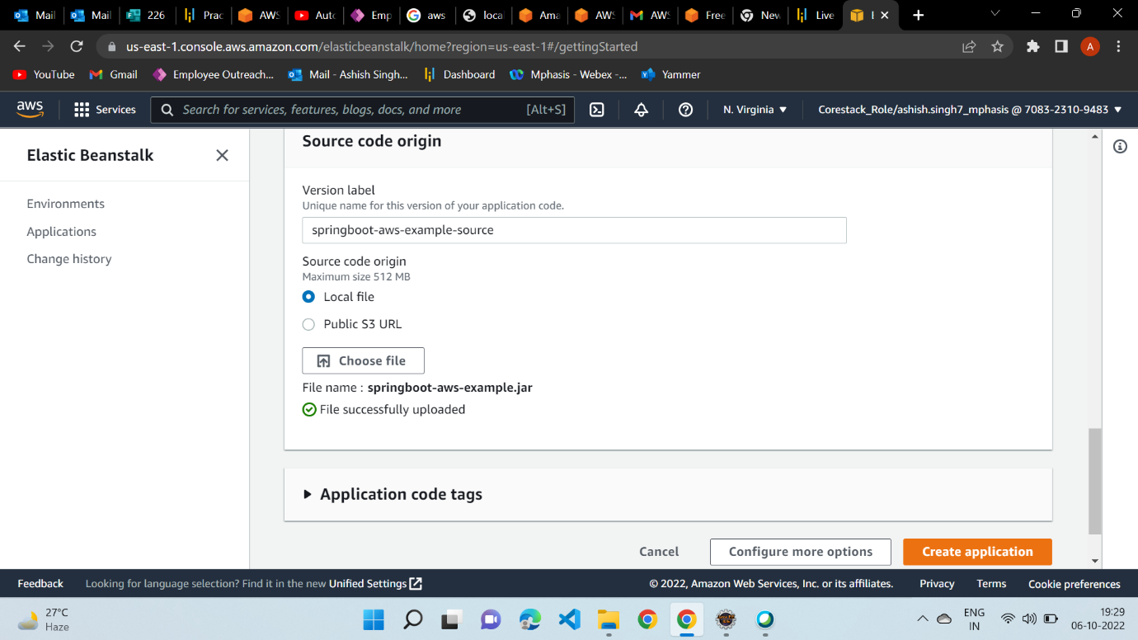

**5. 52.207.253.66:8080**

**IPv4 Public IP**

**Output on aws Server**

